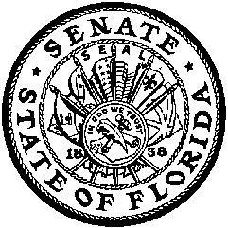
THE FLORIDA SENATE
COMMITTEE ON GAMING
Senator Garrett Richter, Chair
Senator Maria Sachs, Vice Chair
Senate’s Website: www.flsenate.gov

Memorandum

To: | Members of the Senate Committee on Gaming
From: | Senator Garrett Richter, Chair
Subject: | Upcoming Gaming Committee Meetings
Date: | February 7, 2014

During the Gaming Committee meeting last Monday, I announced plans to publish the first DRAFT of a comprehensive gaming bill shortly before our February 10 committee meeting. That timing was driven by: (1) my goal to get the proposed committee bill on our agenda for February 17, and (2) Senate policy that a proposed committee bill be published on the Senate website prior to inclusion on a meeting notice (by February 10 for the meeting on February 17).

As it turned out, we did not finish the workshop on “elements and options” for inclusion in the proposed committee bill. Our discussion was helpful and productive, but there simply was not enough time to cover the issues presented. That being the case I think the right choice now is to postpone filing the proposed committee bill until the committee completes its high-level review.

On February 10, the Gaming Committee will continue consideration of “elements and options.” If we finish, and I expect we will, we will not meet on February 17. If more meeting time is required before the initial draft is published, we can meet again on February 17.

In either case, I expect to publish the proposed committee bill onFebruary 24 and to take it up for the first time during the week of March 3. As discussed when we last met, the SPB likely will be deliberated, discussed, potentially amended, and temporarily passed several times before the Gaming Committee considers a motion to introduce it as a committee bill.

